Peripheral Nervous System: Afferent Division

* **Visceral afferent** (internal organs, subconscious except pain) vs **Sensory afferent** (body surface / muscles / joints, mostly conscious)
* **Somatic senses** (body senses, physical) vs **special senses** (vision, smell, equilibrium, …)
* **Labelled lines**: chains of neurons in the somatosensory pathway, accomplish progressively more sophisticated processing of the sensory information
  + first-order, second-order, third-order sensory neurons
  + receptor => spine => thalamus => cerebral cortex
* **Sensory receptors**:
  + Receptors can be **specialized ending** of the afferent neuron (stimuli directly triggers Na channels), or a **separate receptor cell** closely associated with the dendrite of the afferent neuron (cell release chemicals like synapse)
  + Both produces graded potential: **generator potential** (if specialized ending) or **receptor potential** (if separate cell)
* Sensory receptor types:
  + **Thermoreceptors**: heat
  + **Mechanoreceptors**: pressure / deformation
    - Ex: pacinian corpuscle - large receptor fields, gross pressure changes in deep tissues (vibration detection)
  + **Photoreceptors**: light
  + **Chemoreceptors**: chemicals / ions
  + **Nociceptors**: pain
  + Proprioceptors, baroreceptors, osmoreceptors, …
* **Transduction**: conversion of stimuli to electrical signal / AP
  + Distinguish signals through **MILD** (**modality**, **intensity**, **location**, **duration**)
    - Intensity can be both frequency and number of receptors activated
  + **Adequate stimulus**: type of stimuli the receptor responds best to, can respond to other stimuli (create similar respond since **modality of receptor** is the same)
* **Sensory Adaptation** decrease intensity when stimuli continuously present
  + **Tonic receptors**: do not / mildly adapt (muscle, joints, need continuous signals)
  + **Phasic receptors**: rapidly adapt, respond to change in stimuli (tactile)
* **Receptive field**: responsive region, size varies inversely with receptor concentrations
  + **Lateral inhibition**: inhibitory interneurons between parallel sensory neurons, stronger stimuli inhibit weaker stimuli around it for sharper / finer sensations
  + Ex: small receptive field on finger tip vs on your back
* **Pain**: protective mechanism
  + Nociceptors: **free nerve endings**, **tonic** (do not adapt)
  + **Thermal**, **mechanical**, or **polymodal** (respond equally to multiple types)
    - Fast pain: thermal & mechanical, sharp and localized, fast (myelinated)
    - Slow pain: polymodal, dull aching, unlocalized and persistent, no myelin
  + **Substance P**: pain neurotransmitter, actives ascending pathways (signal to spine)
    - **Opioids**: inhibit release of substance P, analgesia
      * Ex: endorphins, enkephalins, dynorphin, heroin, morphine
  + **Pain modulation**: nearby receptors can inhibit nociceptors (pressing on wound triggers mechanoreceptors that will inhibit nearby nociceptors)

Peripheral Nervous System: Efferent Division

* Text

  Description automatically generated with medium confidence**Acetylcholine** & **norepinephrine**: only two neurotransmitters used by effector neurons
* **Somatic nervous system**: voluntary, motor neurons to skeletal muscle; 1 efferent neutron and no junctions
  + **Final common pathway**: only way other parts of the nervous system influence skeletal muscle is by acting on motor neurons
  + **Motor neurons**:
    - Cell bodies in ventral horn (for muscles in head are in brain stem)
    - Axon continuous from CNS to end (skeletal muscle)
    - Releases acetylcholine – excitation and contraction of muscles
    - Can only stimulate muscles but not inhibit
  + **Neuromuscular junctions**: linkage of motor neurons and skeletal muscle fibres
    - Axon loses myelin, divides into many branches, and forms neuromuscular junction with one of the many muscle cells / fibres in the whole muscle
    - **Terminal button**: knoblike structure of the axon terminal
    - **Acetylcholine** released like in synapse, destroyed by acetylcholinesterase
    - **Acetylcholinesterase** (AChE):
      * Constant relaxation, ACh only binds briefly
      * As soon as ACh (neuron AP) stops, muscle relaxes
    - **ONLY excitatory**, inhibition must be in CNS before NMJ
* **Automatic nervous system** (ANS): involuntary, controls internal organs; controlled by hypothalamus, brain stem, and spinal cord
  + Autonomic nerve pathways: always a **two-neuron chain**, axon of first neuron (**preganglionic fibre)** synapse with second neuron in a ganglion (neurons outside CNS), axon of second neuron (**postganglionic fibre**) connects with effector organ
    - One preganglionic => multiple postganglionic => multiple targets
    - Postganglionic fibres end in **varicosities** (knobs on tissue surface), release neurotransmitter over a large area (innervate organs rather than cells)
  + 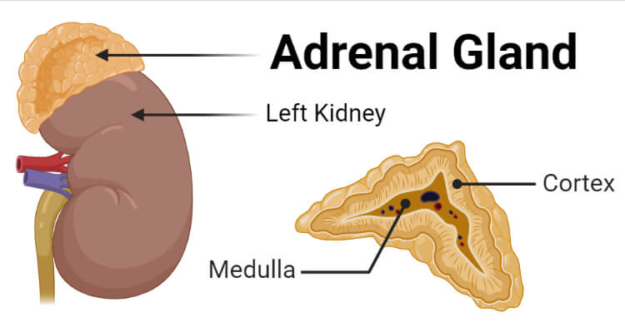**Adrenal medulla**: modified sympathetic ganglion that does not give rise to postganglionic fibres, releases 2:8 **norepinephrine** (noradrenaline) and **epinephrine** (adrenaline)
  + **Antagonistic** (stopping one and activating the other, faster, most organs use this) vs **tonic** (control with only one, blood vessels & sweat glands only sympathetic)
  + **Agonists** (bind to same receptor to mimic transmitter) vs **antagonists** (bind to same receptor to block transmitter) drugs
  + **Regeneration**: governed by growth factor from **Schwann cells** (PNS glial cells, produce myelin sheath)
  + 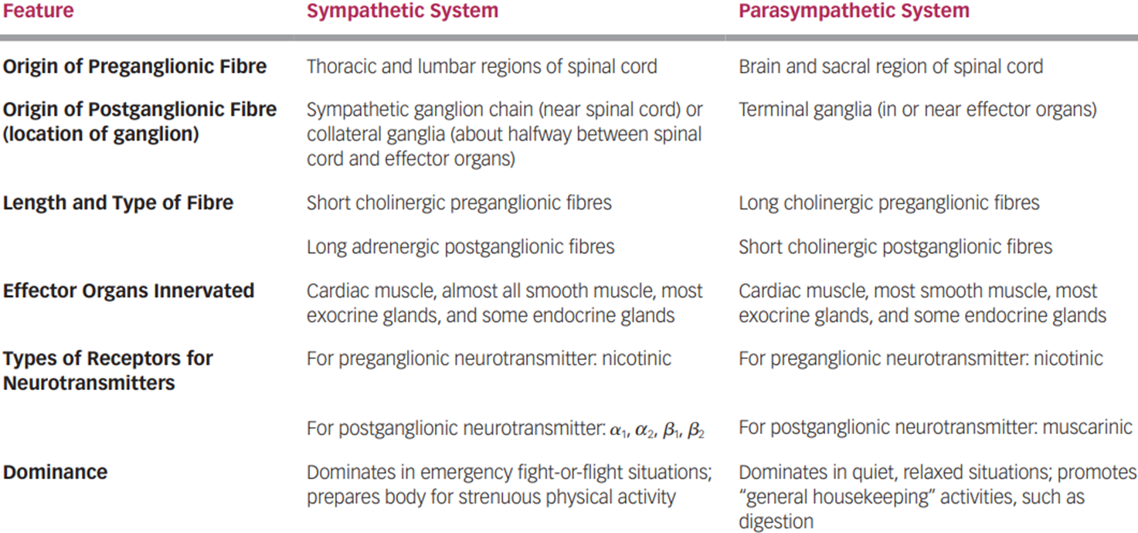**Vagus**: cranial nerve X, 75% of all parasympathetic fibres, control visceral organs
  + Neurotransmitters & receptors:
    - Preganglionic neurons & SNS all release Ach:
      * **Nicotinic** receptors: found on the postganglionic cell bodies in all autonomic ganglia, depolarizes in respond to acetylcholine
    - Postganglionic neutrons release Ach and norepinephrine:
      * **Muscarinic** receptors: found on effector cell membranes, respond to acetylcholine released from parasympathetic fibres only
      * 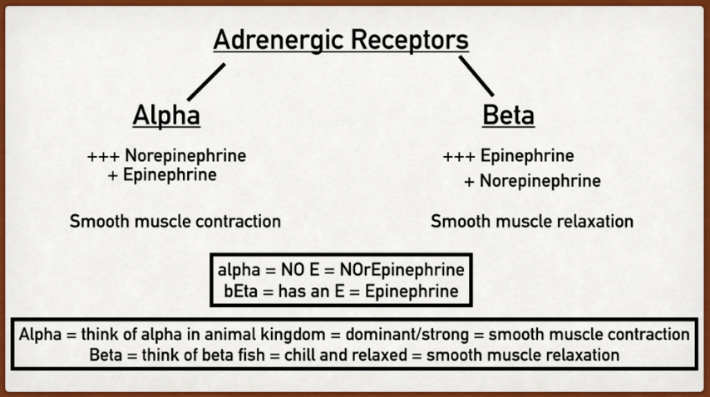**Adrenergic** receptors: respond to epinephrine and norepinephrine; transfer signal into the cytoplasm, influence metabolic processes and cellular function; , , , , types

